Bug 1:
- Title: API ignores id field in POST request and generates a new one
- Priority: High
- Severity: High
- Steps to Reproduce:
  - Send a POST request to https://wmxrwq14uc.execute-api.us-east-1.amazonaws.com//api/employees with a valid id field in the body
{
"id": "92d06160-3699-4ae0-b503-85f5d848ed57",
}
  - Observe the response payload.
- Expected Result:
  - The response should retain the same id value provided in the request.
- Actual Result:
  - The response returns a different, auto-generated id
"id": "f1fbf305-ad77-4d1a-a6de-3e161e61a2b9"

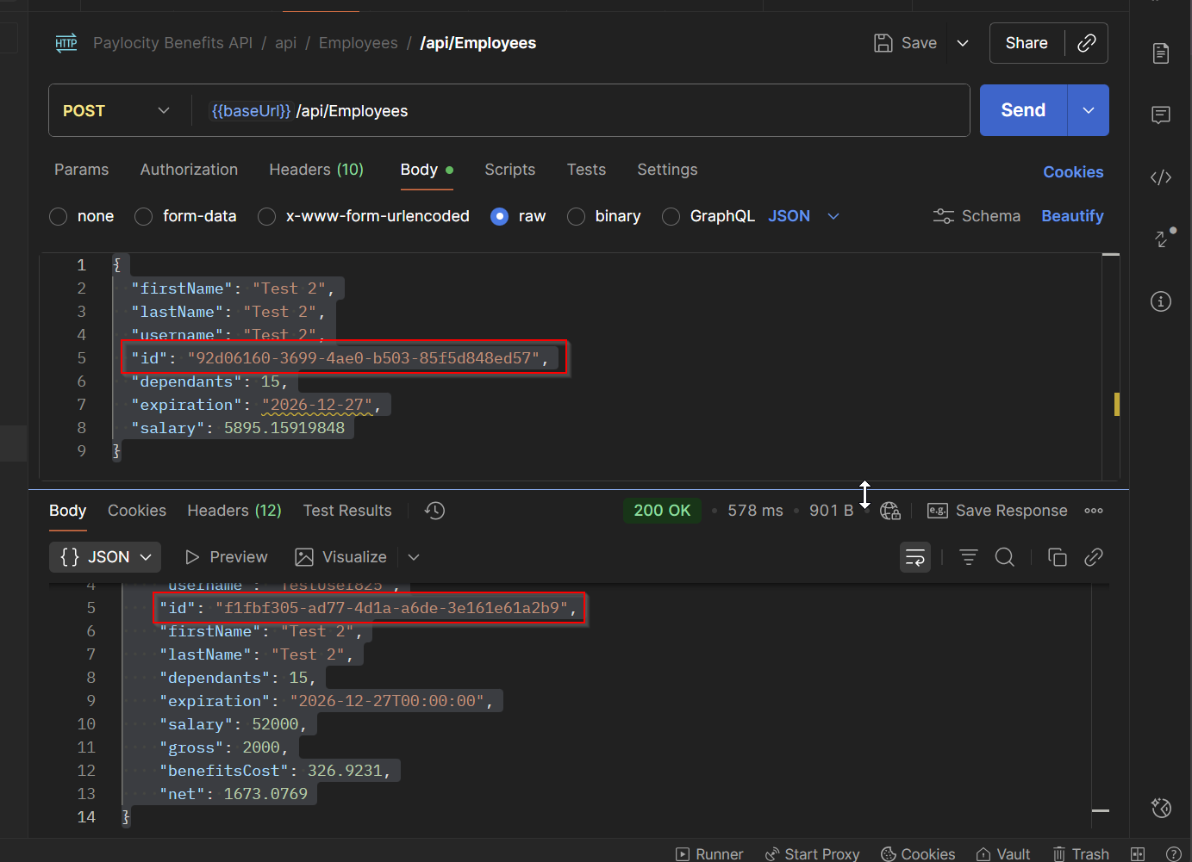

Bug 2:
- Title: API overwrites salary field with hardcoded value of $52,000
- Priority: High
- Severity: High
- Steps to Reproduce:
  - Send a POST request to /api/employees with a custom salary value:
{
"salary": 5895.15919848,
}
  - Observe the response payload.
Expected Result:
- The response should reflect the same salary value provided in the request.
Actual Result:
- The response returns a fixed salary of 52000, ignoring the input
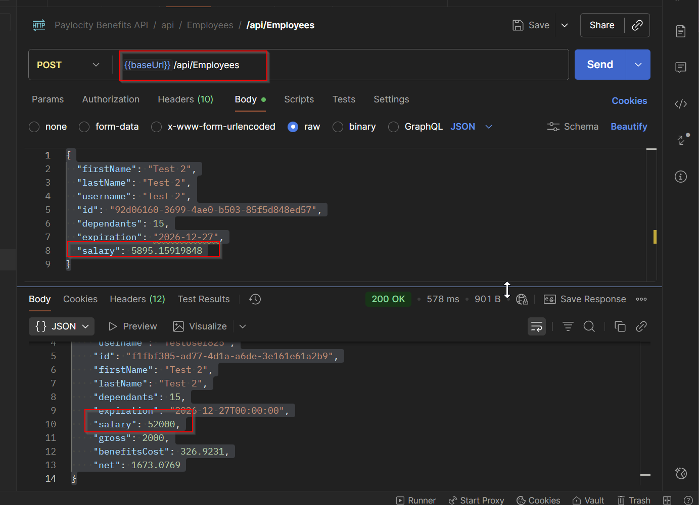
Bug 3:
- Title: Typo in response GET for dependents object
- Priority: Medium
- Severity: Medium
- Steps to Reproduce:
  - Go to https://wmxrwq14uc.execute-api.us-east-1.amazonaws.com/Prod/Account/LogIn
  - Login to the application using credentials
  - Open DEV TOOLS and go to Network
  - On Paylocity Benefits Dashboard page, locate employees request to GET the list of employees
  - Take a look to the dependants object
- Expected Result:
    - It should be displayed as “dependents”
- Actual Result:
    - It’s displayed as “dependants”
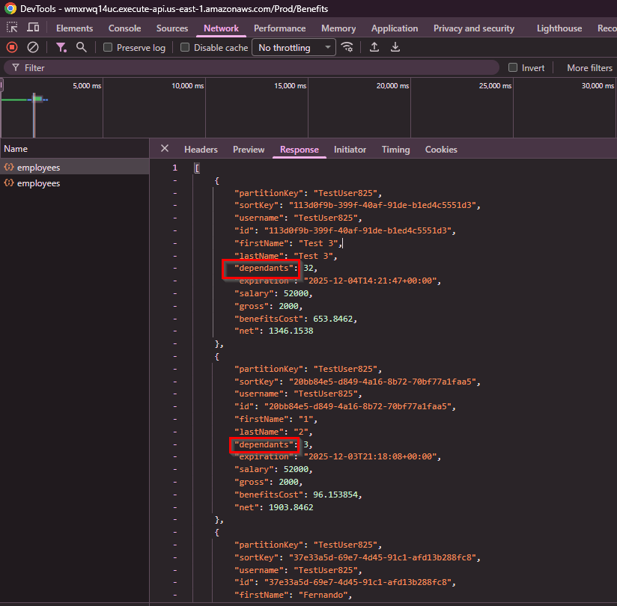

Bug 4:
- Title: Wrong status code while creating a new Employee
- Priority: High
- Severity: High
- Steps to Reproduce:
  - Send a POST request https://wmxrwq14uc.execute-api.us-east-1.amazonaws.com/api/employees using following body:
{
"firstName": "Test 8",
"lastName": "Test 8",
"username": "Test 8",
"id": "92d06160-3699-4ae0-b503-85f5d848ed57",
"dependants": 0,
"expiration": "2026-12-27",
"salary": 0
}

- Expected Result:
    - Status code 201 Created for successful POST should be returned
- Actual Result:
    - A status code 200 is returned instead:
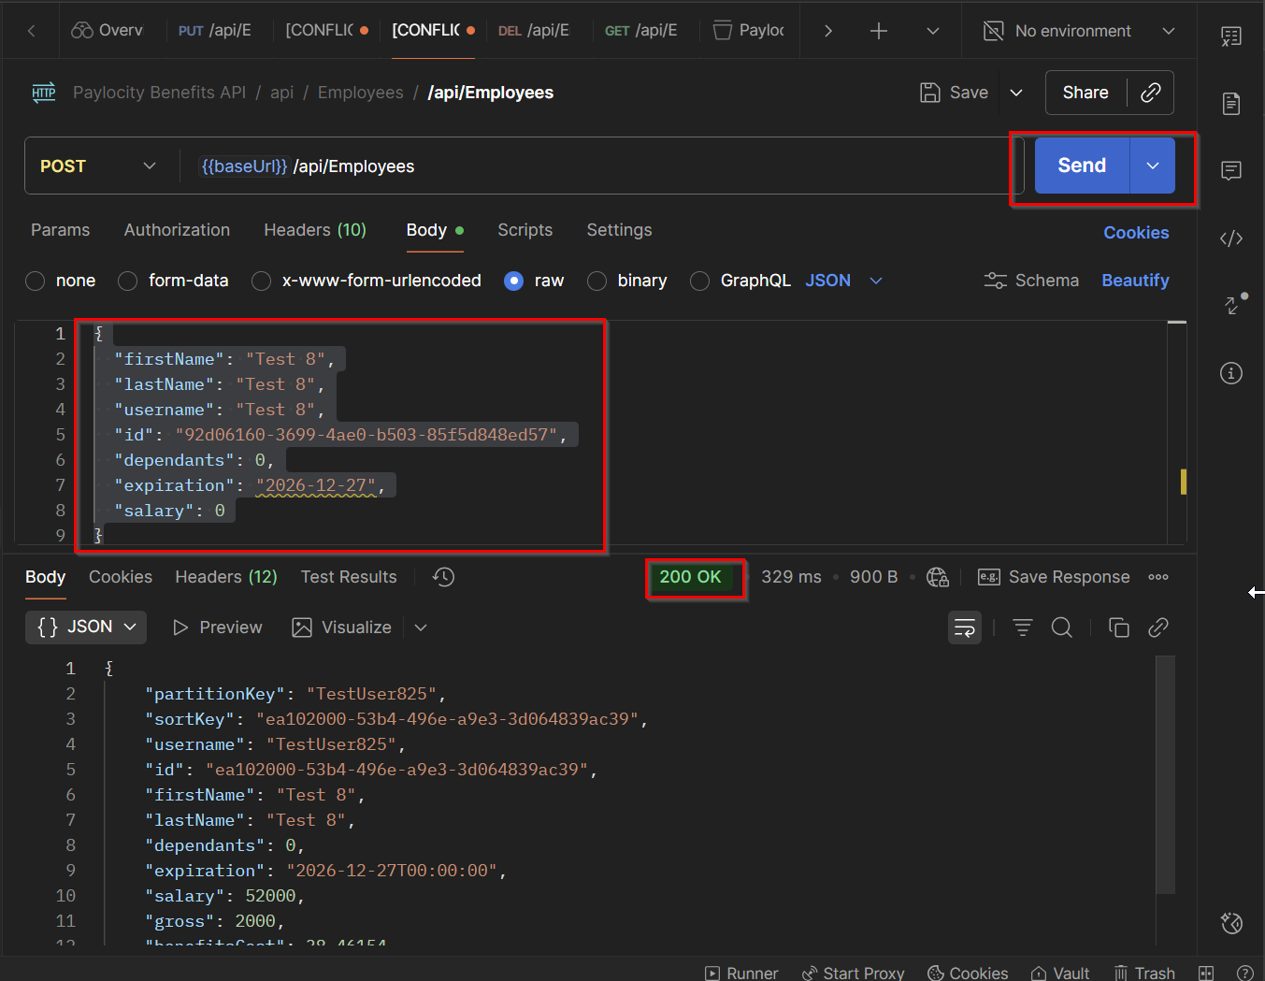

Bug 5:
- Title: Wrong status code while delete an Employee
- Priority: High
- Severity: High
- Steps to Reproduce:
  - Send a POST request https://wmxrwq14uc.execute-api.us-east-1.amazonaws.com/api/employees/ using following body:
{
"firstName": "Test 8",
"lastName": "Test 8",
"username": "Test 8",
"id": "92d06160-3699-4ae0-b503-85f5d848ed57",
"dependants": 0,
"expiration": "2026-12-27",
"salary": 0
}
  - Then send a DELETE request https://wmxrwq14uc.execute-api.us-east-1.amazonaws.com/api/employees/<usedIDgeneratedonstep1>
- Expected Result:
    - Status code 204 No Content for successful DELETE should be returned
- Actual Result:
    - A status code 200 is returned instead:
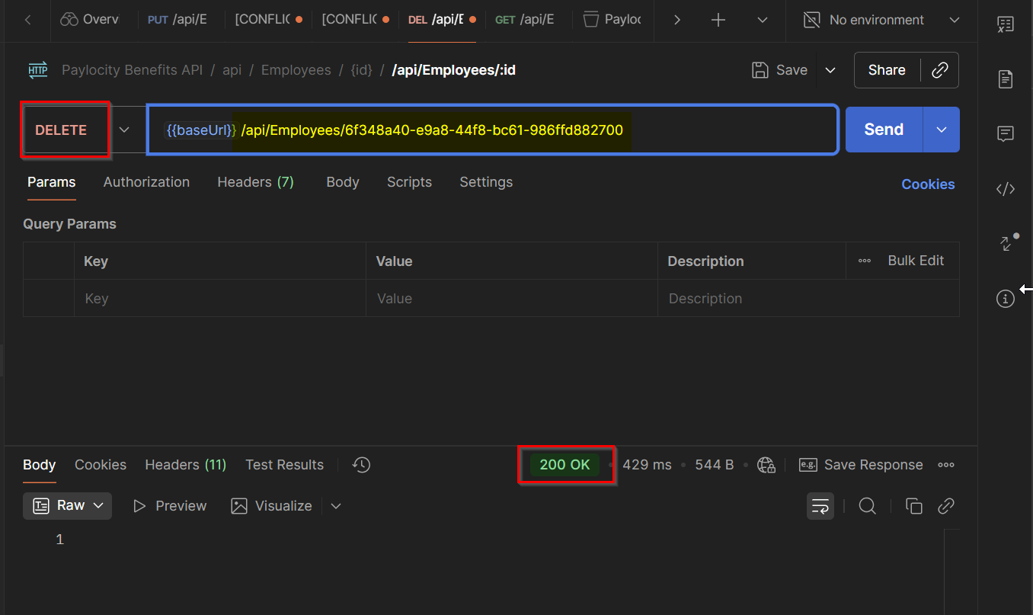

Bug 6:
- Title: Wrong status code for invalid IDs - DELETE
- Priority: High
- Severity: High
- Steps to Reproduce:
  - Send a DELETE request https://wmxrwq14uc.execute-api.us-east-1.amazonaws.com/api/employees/<usedrandomGUID>
- Expected Result:
    - Status code 404 Not Found for invalid IDs should be returned
- Actual Result:
    - A status code 200 is returned instead:
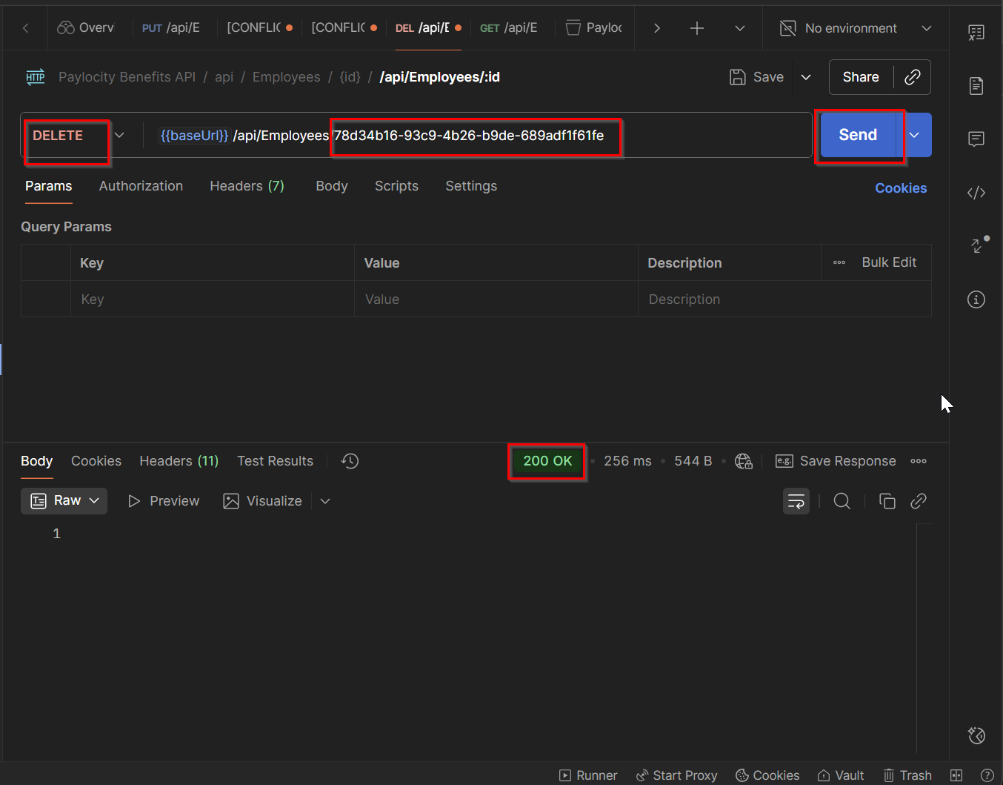

Bug 7:
- Title: Wrong status code for inexisting IDs – PUT
- Priority: High
- Severity: High
- Steps to Reproduce:
  - Send a PUT request https://wmxrwq14uc.execute-api.us-east-1.amazonaws.com/api/employees
  - ID = random ID
{
"firstName": "string 9",
"lastName": "string 9",
"username": "string",
"id": "cffc91c0-6df6-4923-b71b-37bc40e4dae1",
"dependants": 23,
"expiration": "1963-12-27T15:55:57.219Z",
"salary": 5612.346709585782
}

- Expected Result:
    - Status code 404 Not Found for invalid IDs should be returned
- Actual Result:
    - A status code 200 is returned instead and the employee is created:
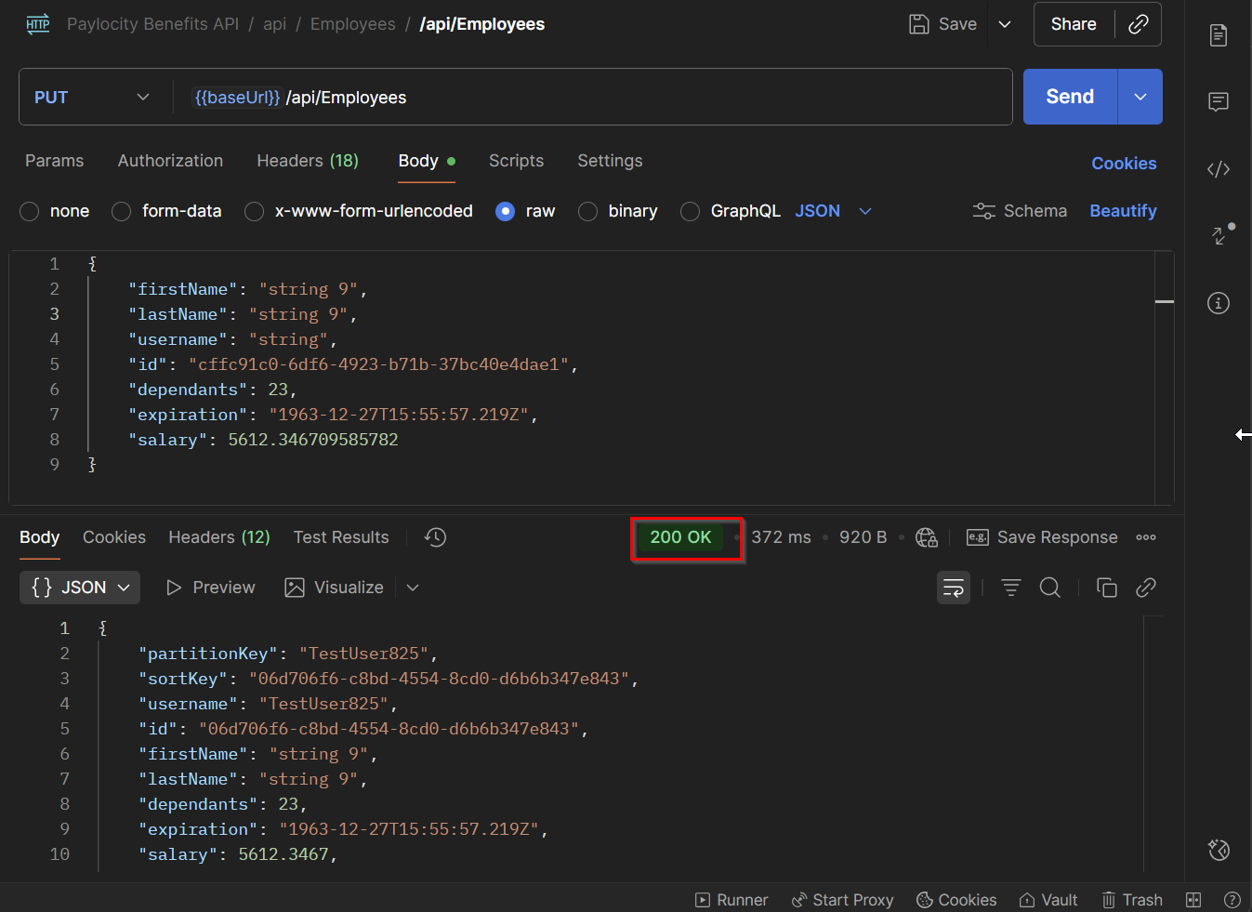

Bug 8:
- Title: Wrong status code when using Invalid data - POST
- Priority: High
- Severity: High
- Steps to Reproduce:
  - Send a POST request https://wmxrwq14uc.execute-api.us-east-1.amazonaws.com/api/employees using following body
{
"firstName": "",
"lastName": "",
"username": "",
"id": "60-3699-4ae0-b503-85f5d848ed57",
"dependants": null,
"expiration": "2026-12-27",
"salary": null
}

- Expected Result:
    - Status code 400 Bad Request along with following messages:
      - firstname shouldn’t be null
      - lastname shouldn’t be null
      - username shouldn’t be null
      - invalid guid format
      - salary shouldn’t be null
      - dependents shouldn’t be null
- Actual Result:
    - A status code 405 Method not Allowed is returned
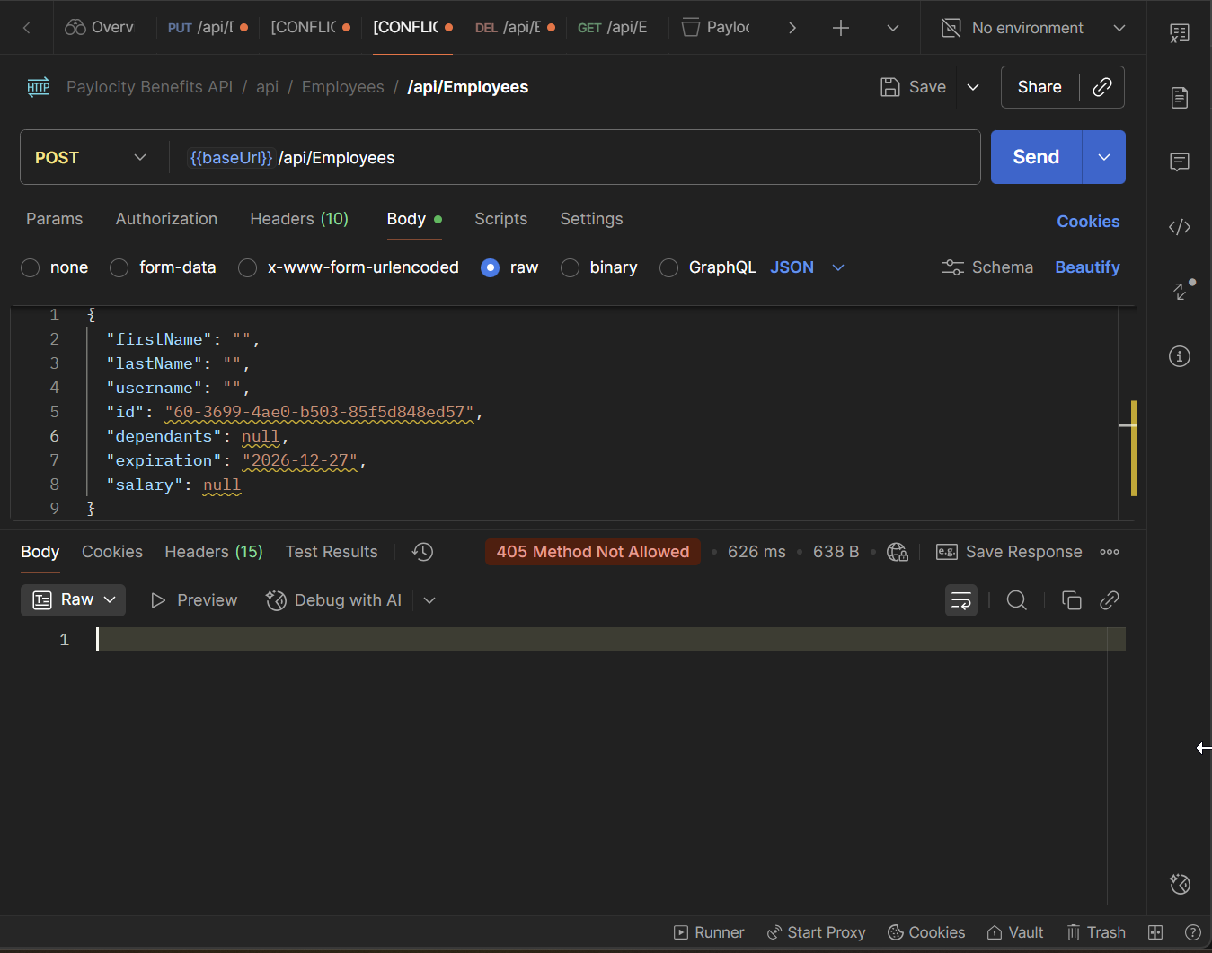

Bug 9:
- Title: Wrong status code for invalid format GUID - DELETE
- Priority: High
- Severity: High
- Steps to Reproduce:
  - Send a DELETE request https://wmxrwq14uc.execute-api.us-east-1.amazonaws.com/api/employees/<invalidformatGUID>
- Expected Result:
    - Status code 400 Bad Request for invalid format GUIDs should be returned
- Actual Result:
    - A status code 405 Method not Allowed is returned
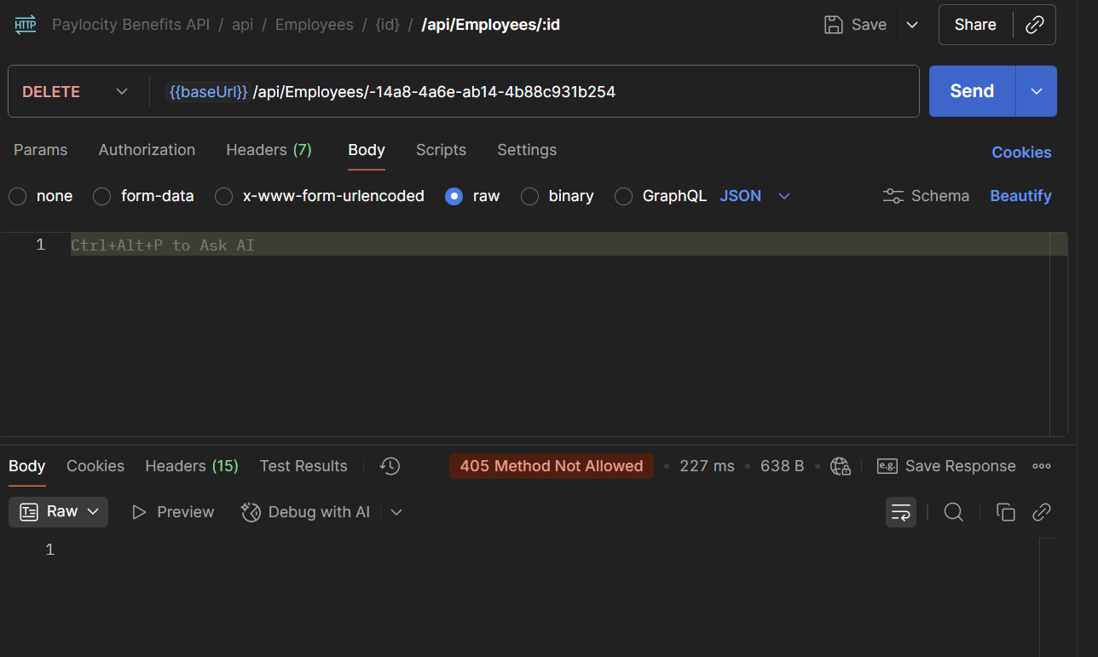

Bug 10:
- Title: Wrong status code for inexisting GUID – GET (by ID)
- Priority: High
- Severity: High
- Steps to Reproduce:
  - Send a GET request https://wmxrwq14uc.execute-api.us-east-1.amazonaws.com/api/employees/<randomGUID>
- Expected Result:
    - Status code 404 Not Found for invalid GUIDs should be returned
- Actual Result:
    - A status code 200 OK is returned
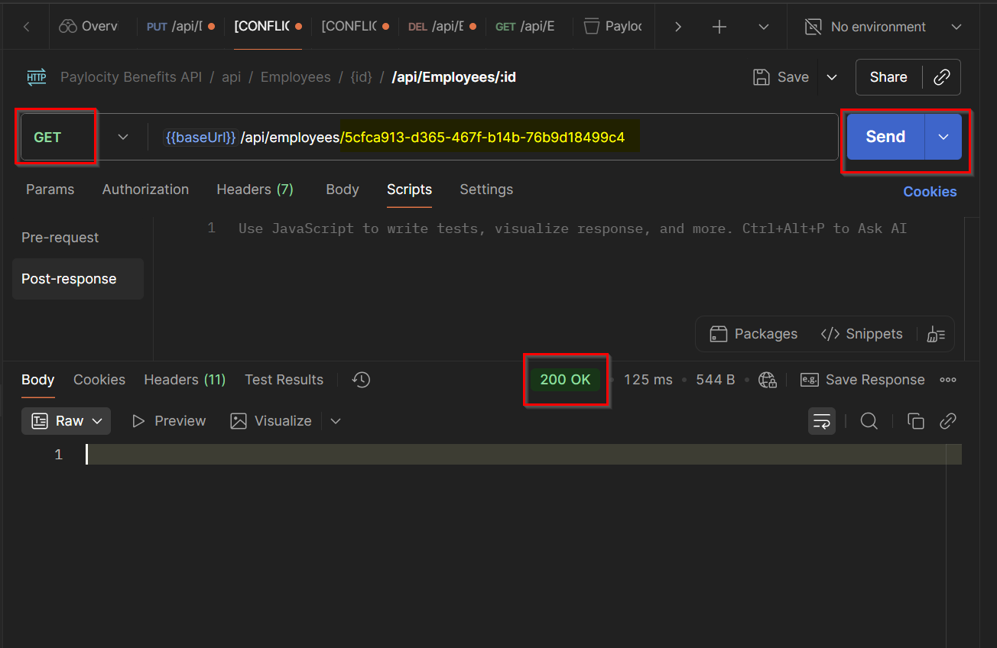

Bug 11:
- Title: Wrong status code for invalid format GUID – GET (by ID)
- Priority: High
- Severity: High
- Steps to Reproduce:
  - Send a GET request https://wmxrwq14uc.execute-api.us-east-1.amazonaws.com/api/employees/<invalidformatGUID>
- Expected Result:
    - Status code 400 Bad Request for invalid format GUIDs should be returned
- Actual Result:
    - A status code 500 Internal Server Error is returned
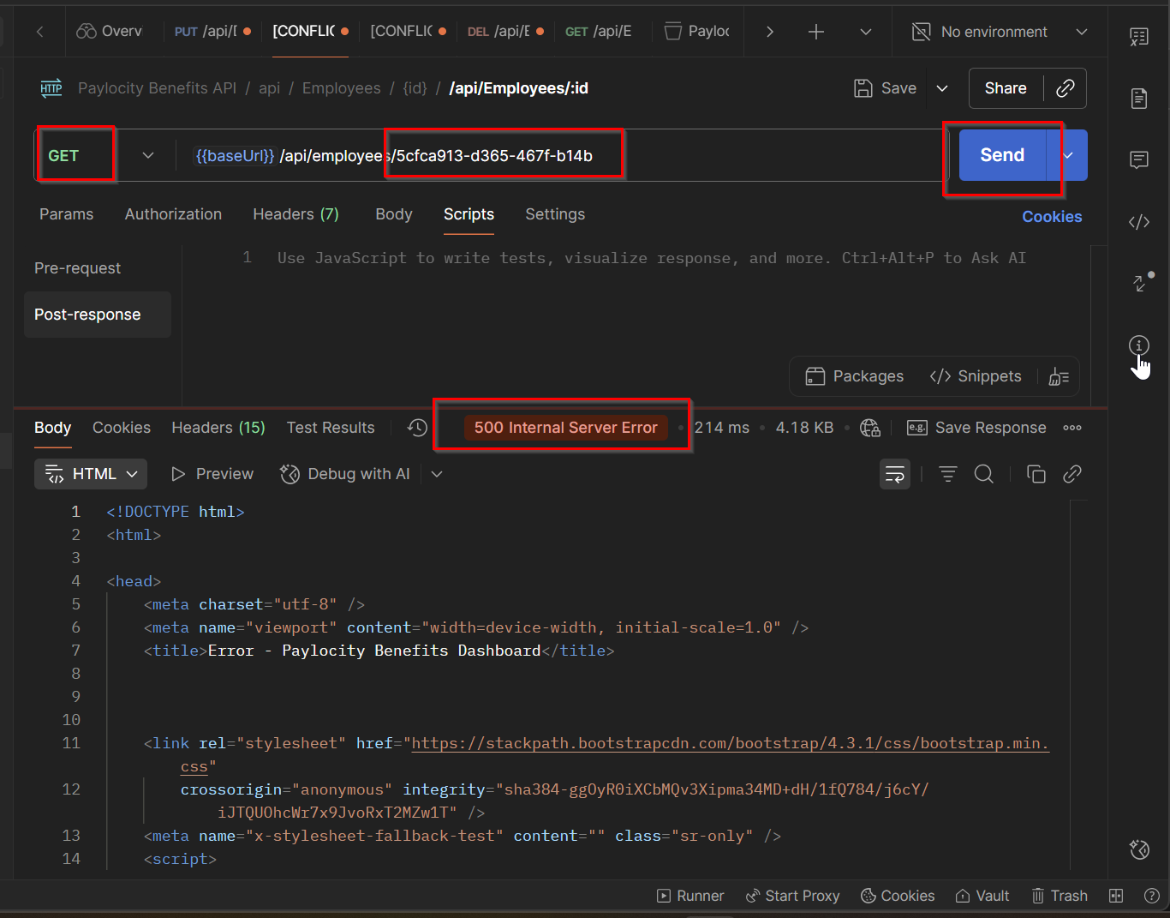

Bug 12:
- Title: {id} parameter should be defined in the path – PUT
- Priority: High
- Severity: High
- Steps to Reproduce:
    - Go to PUT /api/Employees
- Expected Result:
    - {id} for employee should be requested and defined in the path for PUT request
- Actual Result:
    - Not asking for {id] in the request
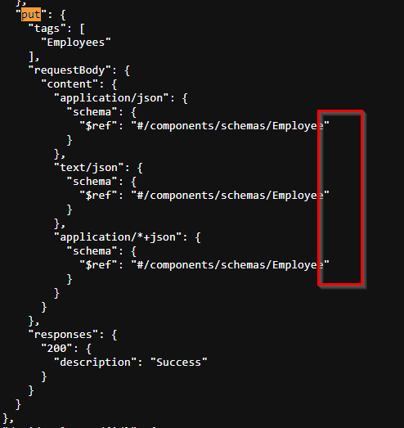

Bug 13:
- Title: No query parameters for pagination, filtering or sorting – GET
- Priority: High
- Severity: High
- Steps to Reproduce:
  - Send a GET (list) request https://wmxrwq14uc.execute-api.us-east-1.amazonaws.com/api/employees
- Expected Result:
    - User should be able to use limit, offshore, filter and sorting criteria
- Actual Result:
    - List of employee is returning with no pagination, filtering or sorting criteria
